THE PRESS OF ATLANTIC CITY
FEATURED TOP STORY
EAST LYNNE THEATER DIRECTOR TAKES HER FINAL BOW
VINCENT JACKSON For The Press
Dec 12, 2022 6

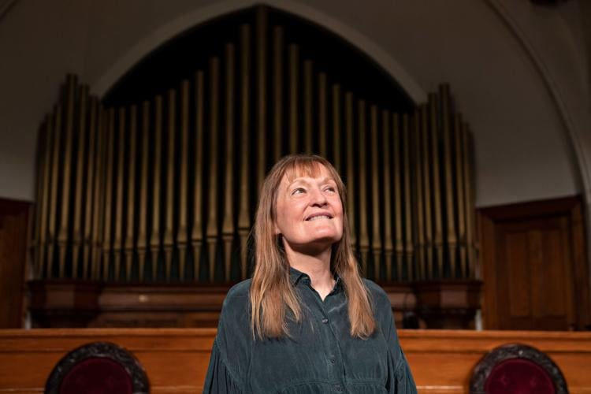

Gayle Stahlhuth is planning to step away this month after 23 years at the helm of the East Lynne Theater Company in Cape May. “I love working with actors and directing, but all the other stuff is a real grind,” she said. (Photo: MATTHEW STRABUK, FOR THE PRESS)
The employment history of actress, director and playwright Gayle Stahlhuth has included everything from making and rebuilding elephant and llama blankets for Ringling Bros. and Barnum & Bailey Circus to adopting an undercover identity for a New York City detective agency to ferret out white-collar crime.

But after a 50-year career in the arts, Stahlhuth likely will be best remembered as the producing artistic director of Cape May’s East Lynne Theater Company from 1999 until the end of this month, preceded by her service on its Board of Trustees from 1987 to 1997.
A resident of West Cape May and New York City, Stahlhuth’s last day with the company will be Dec. 20.

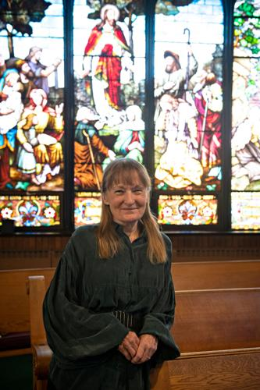

Gayle Stahlhuth has worked in the arts for 50 years. Twenty-three years ago, she became the second producing artistic director in the history of the East Lynne Theater Company, following Warren Kliewer. (Photo: Matthew Strabuk)
“I have been very fortunate,” Stahlhuth said, adding she has done marketing, financial management, house managing, costumes and written plays for the theater over the years. “I love working with actors and directing, but all the other stuff is a real grind.”

Stahlhuth became the second producing artistic director in the theater’s history, following founding artistic director Warren Kliewer.

Before Stahlhuth took over at East Lynne as producing artistic director, she was an actress touring and performing a solo show, “Lou: The Remarkable Miss Alcott.” The show was something she created based on the late American novelist and poet Louisa May Alcott.
As the theater company’s producing artistic director, Stahlhuth was known for supporting female playwrights or women as the central character in plays, including “The Awakening,” adapted from the novel by Kate Chopin; “Edna Ferber,” about the famous novelist and playwright; “A Trunk Without a Label,” about Catharine Beecher, the sister of Harriet Beecher Stowe; “Not Above a Whisper” about Dorothea Lynde Dix; and stories by Zona Gale and Mary Wilkins Freeman.

“Anything I can do to empower women,” Stahlhuth said, adding that many older plays suffer from “Snow White and the Seven Dwarfs” syndrome, with one role for women and seven roles for men. “Hardly ever is that in reverse.”

Stahlhuth has been responsible for more than 100 productions, including 11 New Jersey premieres and 24 world premieres. She directed more than half of them.
Because Stahlhuth has done so many productions over the years, she gave opportunities to many actors, including Thomas Raniszewski, a former member of the theater’s Board of Trustees who currently serves as its manager of social media.

“You don’t always find companies that would treat and value a budding actor with the same respect as one with Broadway and film credits. Gayle does. Everyone was a highly valued equal in Gayle’s eyes. She’s a superstar in my book,” Raniszewski said.

Stahlhuth has driven actors who aren’t feeling well to the doctor, Raniszewski said.

Signs of progress
When Stahlhuth took over as producing artistic director, women held about 10% of such positions in regional theaters nationwide, but the situation has changed a great deal for the better since then, she said.

Kliewer established East Lynne in 1980, dedicating it to the performance, study and preservation of the past 200 years of American theater. No one else in the country was following the same mission at the time, Stahlhuth said. She continued the tradition, but the plays she produced ranged in time from the 1890s to Kurt Vonnegut’s “Who Am I This Time? (& Other Conundrums of Love)” from 1962.

Stahlhuth said her guiding principle has been to present 20th-century American plays that were either relevant or necessary.

“As a nonprofit, I completely believe that taxpayer dollars are helping me do my work,” Stahlhuth said. “It is an honor to be able to procure state and federal funding.”

Stahlhuth has been a pioneer in the artist-in-residence movement to return art to the public schools and is on the artist-in-residence roster in New Jersey, New York, Utah and Wyoming.

Tom Byrn, a Pennsylvania resident, has performed since 2009 with the theater, where he has staged solo shows, just as Stahlhuth has done.

“Professionally, she has a tendency to wear all the hats. She has let go of that a little bit over the years,” said Byrn, who is also one of the theater’s teaching artists. “She’s been open to doing newer plays. ... We were doing older American plays when I got there.”

One example Byrn mentioned was “Possessing Harriet,” a play that made its New Jersey premiere in September at East Lynne. The story, which takes place in 1839, is about a young woman’s fight for freedom. The play, which is by upstate New York playwright Kyle Bass, debuted in 2018 in Syracuse.

“I’m pretty heartbroken. ... I hope she continues to be involved,” Byrn said. “East Lynne will be associated for many years with the name Gayle Stahlhuth.”

Stahlhuth’s life has had big changes the past two years. Her husband, Lee O’Connor, the theater’s technical director from 1999 to 2020, died of cancer last year.

Stahlhuth loves teaching playwriting, theater and directing to students of any age, she said.
“Art must be a part of everyone’s life because people are missing out when it’s not,” Stahlhuth said.

Organizations already are beginning to ask Stahlhuth whether she will take plays she has written on the road. She has connections in New Jersey and New York, and people are inquiring about her availability as a writer, performer and teacher.

Prior to accepting East Lynne’s producing artistic director position, Stahlhuth did everything from radio for the Voice of America to producing a medieval festival at the Walters Art Gallery in Baltimore.

She’s never filled out a job application. The only jobs she hustled and auditioned for were acting jobs, she said.

“I want to stand still and see what happens,” Stahlhuth said, adding she has not had a vacation since 2004. “I think I will stand still at the station, until I see the right train to hop on.”

NOTE: Photos were taken at The Cape May Presbyterian Church where Gayle Stahlhuth has been producing East Lynne Theater Company productions since 1999 when she took over the company. The theater became homeless in 1998.

